Aashish Agrawal

SID- 44009240

Data Tables/ Scenarios & Optimisation

Local Government Area (LGA)

**TASK ONE:**

The LGA chosen for this report is **Ashfield**. The non-strata (house) and strata (apartment) prices reflect prices as of March 2016 adjusted for inflation.

Assumptions:

* The strata (apartment) prices may vary. It could drop to as much as 20% of the reflected price as of March 2016, may remain stable or may jump as much as 15%. All scenarios are shown below.
* Construction cost may vary in the range of 40%,50%,60%
* Number of apartments can be in the range of two to a maximum of eight for one house block. This report only shows different scenarios of apartments that can be built in one block of house instead of changing the number of house blocks.

1. When 1 apartment is built

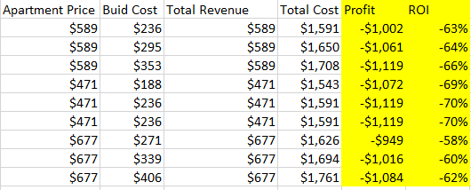

1. When two apartment is built

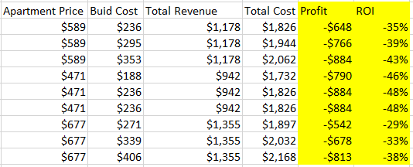

1. When three apartment is built

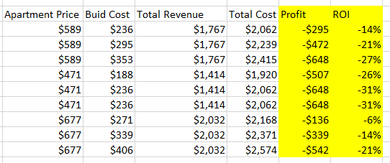

1. When seven apartment is built

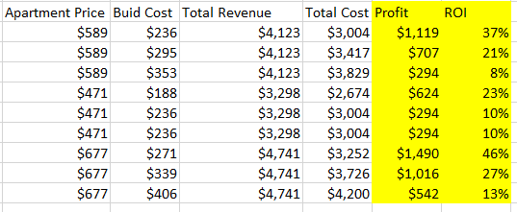

1. When eight apartment is built

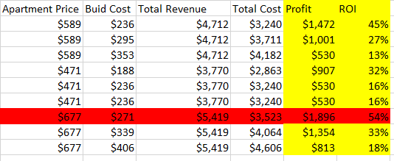

The results from this task is not at all surprising. All it does is provide different scenarios to look into. We can clearly see that for each apartment built, for instance when one apartment was built it provides apartment prices for different scenarios (i.e. when price is stable ($589), 20% decrease ($471), and 15% increase ($677)) along with built cost with different scenarios (i.e. 40%, 50%, and 60%). Data Table/Manager Scenario is used for this case but a more depth detail required some manual work to be done on excel as well. All in all we can clearly conclude that building one apartment in any scenario is going to lead to a loss while building eight apartment if there is a 15% increase in the selling price of the apartment with a 40% build cost is going to lead to profit maximisation of $1.896million with a ROI of 54% (highlighted in red)

**TASK TWO:**

The LGA chosen for this report is **Ashfield**. The non-strata (house) and strata (apartment) prices reflect prices as of March 2016 adjusted for inflation.

Assumptions:

* The number of maximum floors that can be built is 15.
* Each floor consists of apartment from 18-25.
* Since we are looking at our particular LGA, we provide data related specific to it with a slight information comparing it to the LGAs around it.

So, referring to our LGA and performing all sort of calculations and taking into consideration all the constraints, we figured that Ashfield is not a suitable place to make an investment and hence we should not carry on with the project. The result of the optimisation tool in excel helps give the following results:

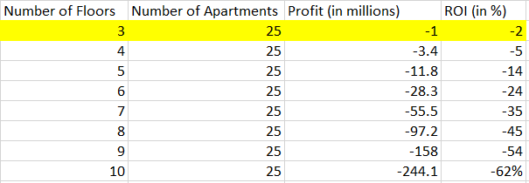

The figure highlighted in yellow is the result produced by the optimisation tool. It clearly shows that we optimise when we build 3 floors with 25 apartments which would still lead to a **loss of 1million and a negative ROI**. Other scenarios are also displayed in the table above but all lead to a loss with the one highlighted in yellow showing the least amongst them. It is definitely not worth investing in this particular LGA. The goal of this report is to optimise the number of floor with number of apartments which would lead to profit maximisation. Clearly, none of the above scenarios supports the project. We also assume that the number of apartments on a particular floor would usually be maximised (i.e. 25 in this case) since it clearly helps minimise cost. We know this especially if we refer to Task one above where we saw that when we build maximum apartments in a particular block of house leads to profit maximisation and greatest ROI.

Since, our particular LGA is not a sound investment to make, here is a list of few of the LGAs around Ashfield that might be suitable if a similar proposal comes up:

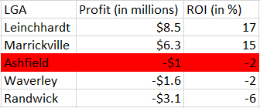

We can see that a proposal at Leinchhardt or Marrickville is definitely worth looking into. They have high profits and ROI. But there are other LGAs which lead to worse results than Ashfield for instance Waverley and Randwick.

**Optimisation Method:** Excel uses Solver to optimise the results. In this case we said that number of apartments is greater than and equal to 18, and less than and equal to 25, while number of floors is at least one, and less than and equal to 15, with both being integers. We use the Evolutionary solving method to get the results. We can clearly make a decision based on these calculations that Ashfield is not suitable for investment and we should decline the proposal.